**Lab 6 - Working with JUnit and JavaFX**

**PART A**

**Determine why during this test add threw the exception and ﬁx the test case**

This test threw an exception and not a failure because we make object of Money m14CAD with a negative amount, and there is an exception there since amount can’t be negative. So we fix it by removing the negative sign from 14.

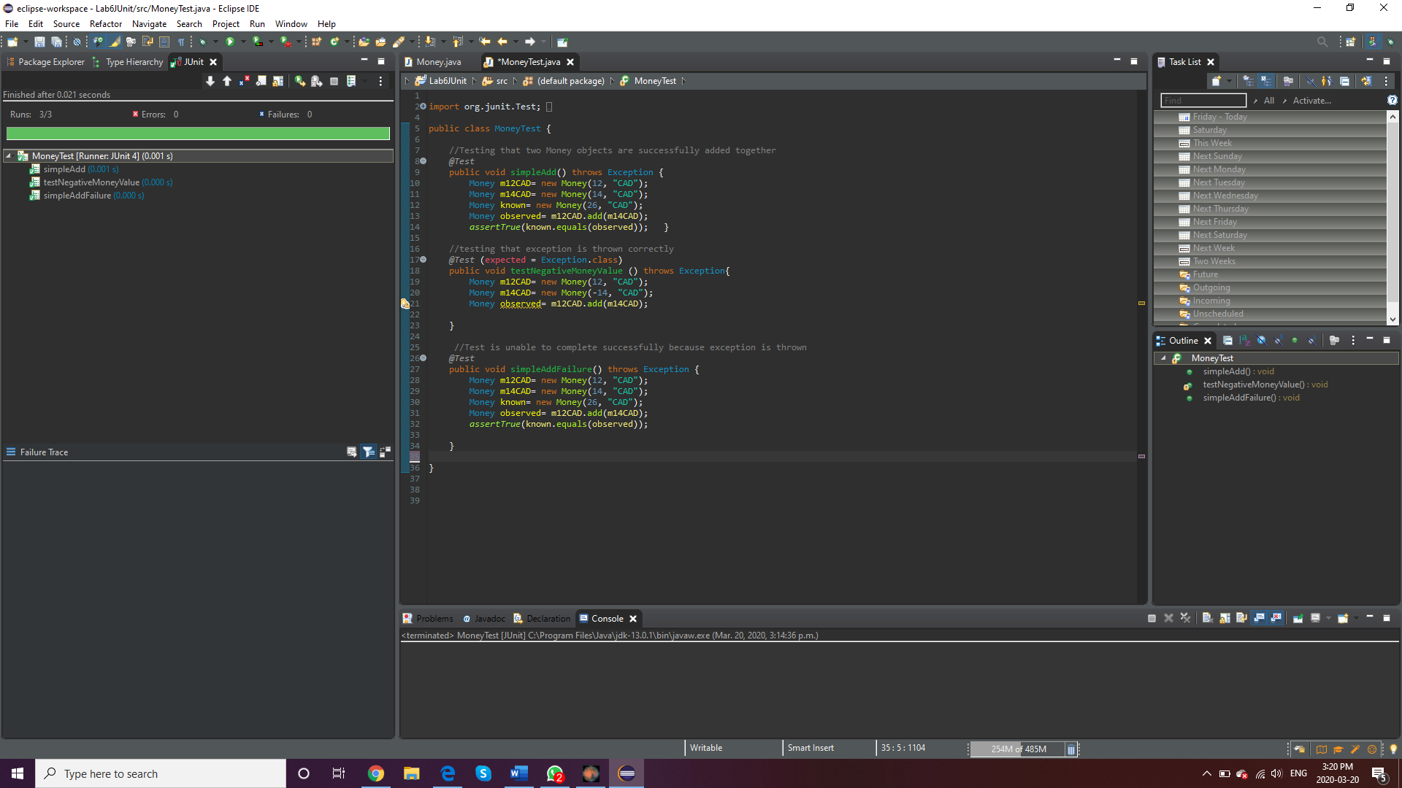

**PART B**

**A screen capture of your ﬁnal FX Pane when your project is running**

